第一篇 Let’s learn词汇的教学
内容：
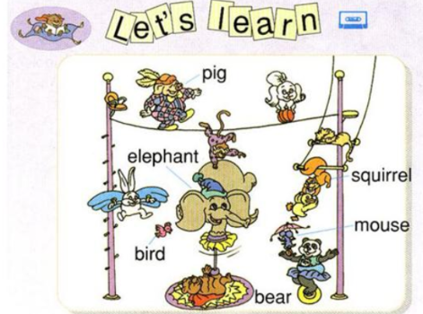
2.基本要求：
- 采用英语授课，试讲时间约10分钟；
- 试讲时需示范朗读教学内容，适当关注语言词调的渗透训练；
- 创设语言情境呈现词汇并组织教学游戏操作词句，突出有难度的词语；
- 配合教学内容适当进行板书，以帮助学生掌握新学知识点。
试讲稿
Leading in
Good afternoon, boys and girls. It’s so good to see you again. Before the lesson, I would like to sing a song with you “Five Little Monkeys”. Well, do you like monkeys? My favourite animal is monkey. This boy, what is your favourite animal? Ok, you like bears. Does anyone else agree with him? Wow, a lot of you guys like bears. Good, bears are cute. you, please, what is your favourite animal? Very good, you said you prefer birds. I believe different people have different preference. But that is ok. And we are going to learn lots of animals today, do you like it? Yes. I can’t wait as well.
Presentation
First of all, let’s look at the attractive pictures. You can see that they are all about animals. Ok, can you see the first picture? Fantastic, what is that? Put up your hands please. You please. Yes, that is an elephant. An elephant has a long nose. Good, everybody, read after me, elephant, elephant, elephant. The boy, please. Good. The girl, please, look at my mouth, [e], [e], elephant. Let’s move to the second picture. Who can tell me what is this? Wonderful, I heard someone said “squirrel”. Yes, boys, read after me, squirrel. Girls, squirrel. Let’s continue. What is that in this picture? Any volunteer? No one? Come on, I know you guys can do it? OK, the second chance, what is that? Good job！That is a pig. The pig is fat.
Practice
Ok, that’s all about the pictures. Boys and girls, let’s play a game. Ok? Now I divide you into two groups, you are Group A, and you are Group B. When I say “bear” in loud voice, you say “bear” in low voice, and when I say “bear” in low voice, you should say “bear” in loud voice. The faster and louder, the winner. Are you clear? Are you ready? Yes! bear (loud voice), bear (low voice)…, you are so fast, give group A one flower. Once again, squirrel (loud voice), squirrel (low voice)…, this time, you are so fast, so I will give group B one flower. The last time, please listen carefully! elephant (loud voice), elephant (low voice), elephant (loud voice), elephant (low voice). Ok，group A is faster and louder, so I will give you one flower.
Consolation
You guys are so confident and smart. I hope that you are creative as well, because I have a task for you right now. Can you draw a picture for your favorite animals on the paper? I will give you 5 minutes. Is that enough for you to finish it? Well, let’s start. Well, time’s up. Anyone wants to share your picture with us? Yes, this girl, please. Wow, very nice picture, the bird looks lovely.
Summary
We have learned so much today. Who can help me to summarize what we have learned in this class? Yes, that boy, please. Is that right? Well done, we have learned a lot of animals today, such as elephant, squirrel, bear and so on. Also, we have learned to love and care about them.
Homework
After the class, will you tell your parents what you have learned today? Very good. Also, can you write a short story about your favourite animals? Wonderful.Then , let’s call it a day. See you tomorrow.

